5.55: a)
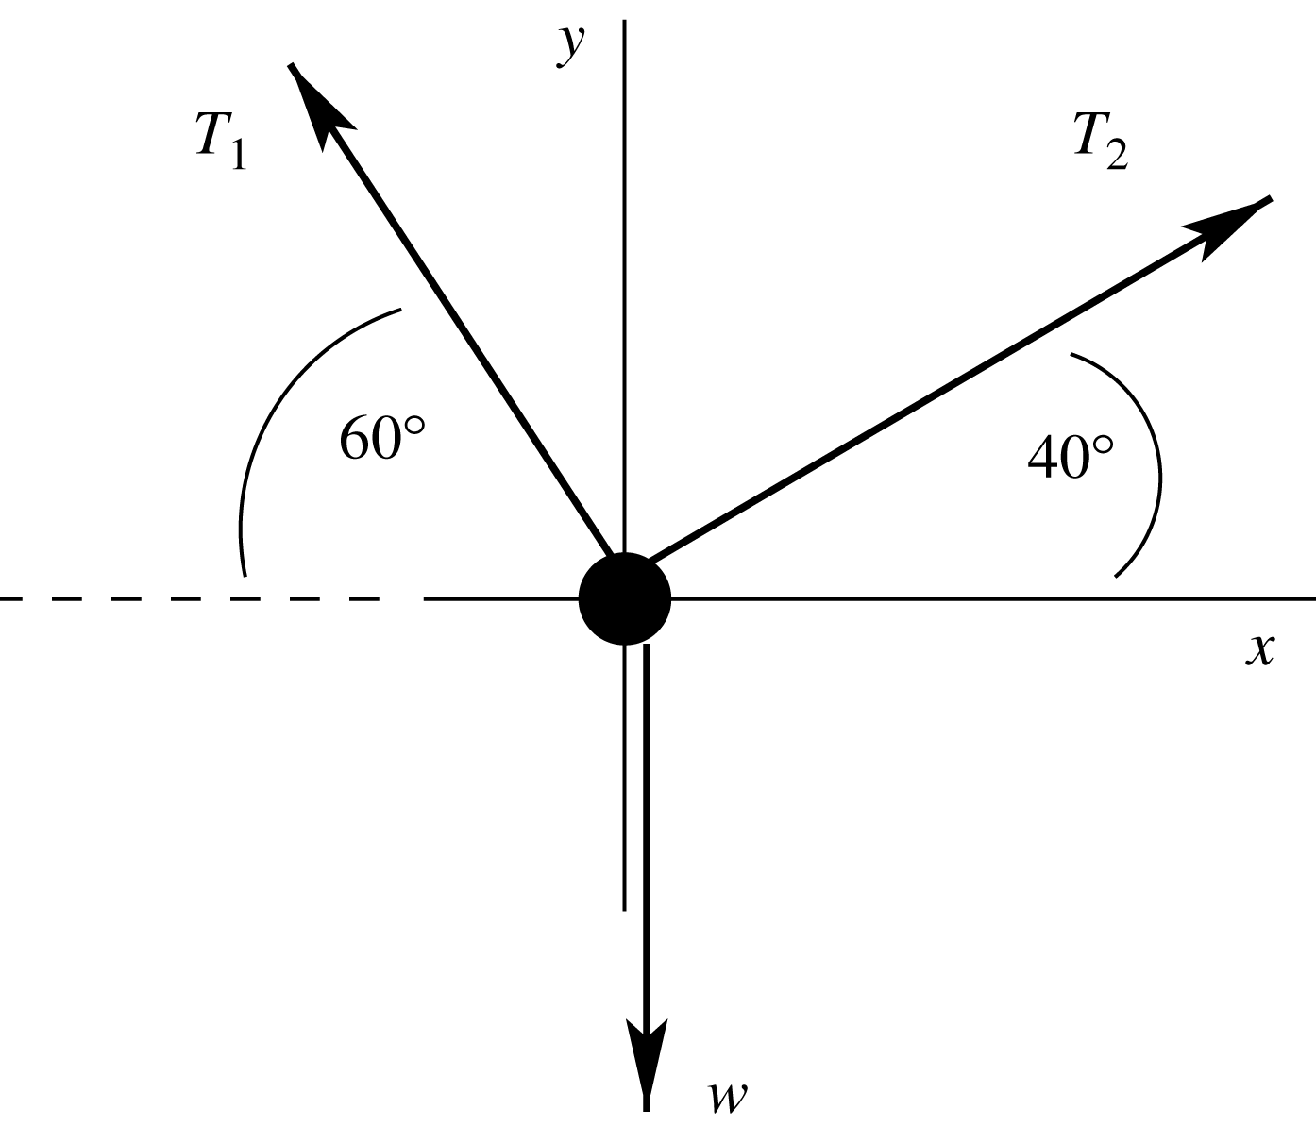
is more vertical so supports more
of the weight and is larger.
You can also see this from 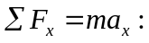
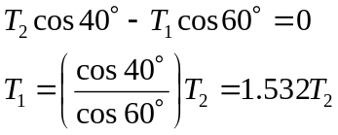
b) is larger so set 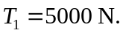 Then 
